Experiment 1
Comparative study of low-code development versus traditional application development approaches.

1.Aim:
The aim of this experiment is to study and compare Traditional Application Development and Low-Code Development by understanding their development methodologies, workflow, coding requirements, development speed, cost, flexibility, maintenance, and suitable application areas. The experiment also analyzes the advantages and limitations of both approaches to determine their effectiveness in modern software development
2. Introduction to Traditional Application Development
Traditional application development is the conventional and most widely used approach for developing software applications. In this method, applications are built by writing source code manually using programming languages such as Java, Python, C#, C++, PHP, JavaScript, or similar technologies. Every component of the software, including the user interface, business logic, database operations, security mechanisms, and system integration, is developed through programming.
This development approach follows a structured Software Development Life Cycle (SDLC), where each stage of development is carried out systematically. The process begins with understanding customer requirements, followed by system planning and design, coding, testing, deployment, and maintenance. Since every module is developed from scratch, developers have complete control over the application's architecture, functionality, and performance.
Traditional development requires a team of skilled software professionals, including software developers, system analysts, database administrators, quality assurance engineers, and project managers.
3. Introduction to Low-Code Development
Low-code development is a modern software development approach that enables applications to be created using graphical user interfaces, drag-and-drop components, visual workflows, and reusable templates with minimal manual coding. Instead of writing thousands of lines of source code, developers configure application logic using visual tools provided by low-code platforms. Only limited programming is required when implementing advanced features or highly customized functionalities.
The primary objective of low-code development is to simplify and accelerate the software development process while reducing dependence on extensive programming knowledge. These platforms provide pre-built user interface components, workflow automation, database connectivity, API integration, authentication mechanisms, reporting tools, and deployment services that significantly reduce development effort.
Low-code platforms support rapid application development by allowing developers to assemble applications visually rather than creating each component manually. This enables organizations to deliver software solutions within weeks or even days instead of several months. As a result, businesses can respond quickly to changing market requirements and customer demands.

4. Diagram for stages in traditional approach.

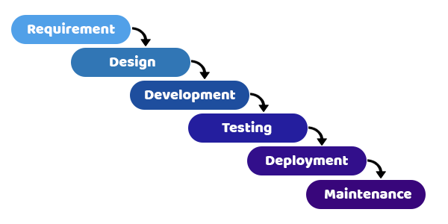

5 Diagram for Steps in Low-Code Development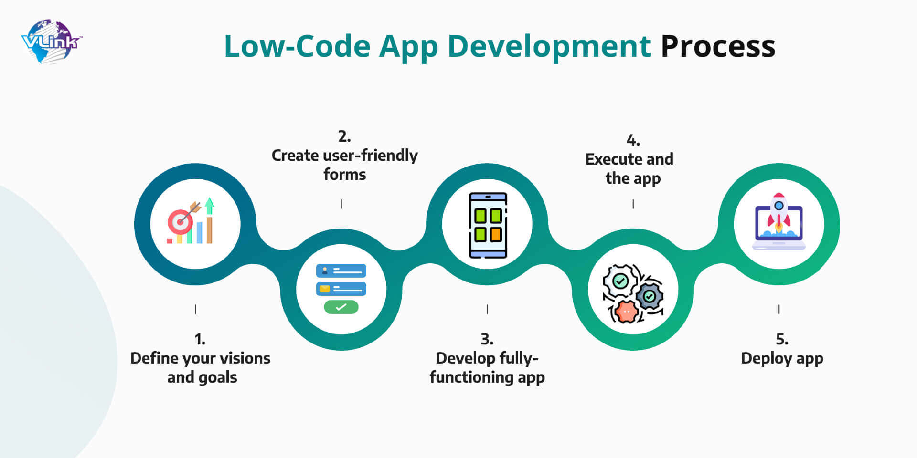

6.Comparative analysis for traditional and low code
Comparison Parameter | Traditional Application Development | Low-Code Development
Definition | A software development approach where applications are built by manually writing source code using programming languages. | A software development approach where applications are created using visual tools, drag-and-drop components, and minimal manual coding.
Development Method | Relies completely on manual programming and coding. | Uses visual development environments with pre-built components and templates.
Scalability |  | Suitable for small and medium-scale business applications but may have scalability limitations for highly complex systems.
  Highly suitable for large-scale enterprise applications with complex requirements.
Examples | Applications developed using Java, Python, C#, .NET, PHP, or JavaScript frameworks. | Applications developed using Microsoft Power Apps, Mendix, OutSystems, Appian, and Zoho Creator.

7. Result
The comparative study shows that both traditional application development and low-code development have their own advantages depending on project requirements. Traditional development offers greater flexibility, scalability, and customization, making it suitable for complex and large-scale enterprise applications. However, it requires significant coding effort, longer development time, and higher costs.

